1. What is the Tableau?
   1. Tableau is a powerful data visualization software that enables users to create interactive and visually appealing dashboards, reports, and charts. It allows users to connect, visualize, and share data from various sources, including spreadsheets, databases, cloud services, and big data platforms. Tableau offers an intuitive drag-and-drop interface, making it easy for users to explore and analyze data without requiring extensive technical skills or programming knowledge. It provides a range of visualization options, including bar charts, line graphs, maps, scatter plots, and more, which can be customized to meet specific needs.
2. What are the tableau components and it’s usage?
   1. There are 5 components of Tableau
      1. Tableau Desktop: This is the authoring tool that enables users to create and design interactive dashboards and reports using a drag-and-drop interface. It allows users to connect to data from various sources and transform it into meaningful visualizations.
      2. Tableau Online: This is a cloud-based version of Tableau Server that allows users to access and share data and visualizations from anywhere with an internet connection.
      3. Tableau Server: This is the web-based platform that enables users to share, collaborate, and publish Tableau dashboards and reports within an organization. It provides a secure environment for data sharing and enables users to control access to their data.
      4. Tableau Reader: Tableau Reader is a free desktop application that allows users to open, view, and interact with Tableau files (.twbx and .twb) created by others. Tableau Reader is designed for users who want to view and explore data visualizations without the need for Tableau Desktop or a Tableau Server license.
      5. Tableau Prep: This component helps users prepare and clean data for analysis. It allows users to combine, shape, and clean data from multiple sources to create a consistent and reliable dataset.
3. How to connect the tableau data source?
   1. to connect a data source in Tableau:
      1. Open Tableau Desktop
      2. Click "Connect to Data"
      3. Choose the type of data source (Excel, CSV, database, etc.)
      4. Enter the necessary information to connect to the data source
      5. Click "Connect" to import your data into Tableau
4. How many types of layers in tableau?
   1. there are four main types of layers
      1. Marks layer: This layer defines the visual representation of your data, such as bars, lines, or points. You can customize the appearance of marks by adjusting their size, shape, color, and other attributes.
      2. Filters layer: This layer allows you to apply filters to your data, so that you can focus on specific subsets of data or exclude certain data points. You can filter data based on different criteria, such as value ranges, date ranges, or categorical variables.
      3. Pages layer: This layer enables you to create animated visualizations that show how your data changes over time or across different categories. You can create multiple pages in your visualization and specify how they transition from one to another.
      4. Reference line/box layer: This layer allows you to add reference lines or boxes to your visualization, which can help highlight important trends or benchmarks in your data. You can set the location, size, and appearance of reference lines/boxes based on specific values or formulas.
5. What the connections in tableau?
   1. There are two main types of connections in Tableau:
      1. Live Connection: In a live connection, Tableau connects directly to the data source in real-time, and any changes made to the data are immediately reflected in your visualization. This type of connection is ideal for working with large data sets, as it allows you to analyze and visualize the data quickly and efficiently.
      2. Extract Connection: In an extract connection, Tableau creates a static snapshot of the data source and stores it in a Tableau data extract (.tde) file. This file can then be used to create visualizations without having to connect to the original data source. This type of connection is ideal for working with slower or more complex data sources, or for cases where you need to work offline or share your data with others.
6. What is the difference between extract filter and datasource filter?
   1. there are two main types of filters: extract filters and data source filters
      1. Extract Filter: This type of filter is applied when the data is extracted from the original data source and before it is brought into Tableau. An extract filter is used to reduce the amount of data stored in the Tableau data.
      2. Data Source Filter: Data source filters are applied before the data is extracted; Data source filters are useful when you want to limit the amount of data that is visible to all users of a workbook. Basically, data source filter is used to exclude certain rows of data from the entire data source.
7. How can we hide and unhide the fields in tableau?
   1. Using the Show/Hide Fields dialog box
      1. 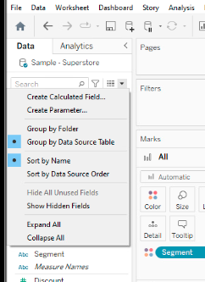
   2. Using the Dimensions and Measures shelves
8. What is the data blending and joins in tableau?
   1. Data blending and joins are two methods used in Tableau to combine data from multiple sources.
      1. Data Blending: Data blending is a technique used to combine data from multiple sources by linking them together based on a common field. In Tableau, data blending is done by creating a relationship between two data sources, where one data source acts as the primary source and the other as a secondary source. Data blending is useful when you have data sources that cannot be easily joined together, such as when the data is stored in different formats or on different servers.
      2. Joins: Joins are used to combine data from two or more tables in the same data source based on a common field. Tableau supports several types of joins, including inner join, left join, right join, and full outer join. Joins are useful when you have data that is stored in different tables within the same database or data source.
9. How to save the tableau file and what are the extensions in tableau?
   1. To save file in Tableau
      1. Click on the "File" menu in the top left corner of the Tableau window.
      2. Select "Save" or "Save As" from the drop-down menu.
      3. Choose the location where you want to save the file.
      4. Enter a file name for the file in the "File name" field.
      5. Click the "Save" button to save the file.
   2. extensions in tableau
      1. Tableau Workbook (.twb)
      2. Tableau Packaged Workbook (.twbx)
      3. Tableau Data Extract (.tde)
      4. ableau Packaged Data Source (.tdsx)
10. Explain the worksheet components?
    1. The components of worksheet:
       1. Columns Shelf: This is where we drag and drop the fields that we want to use as columns in your visualization. These fields typically represent the categories or dimensions of your data.
       2. Rows Shelf: This is where we drag and drop the fields that we want to use as rows in your visualization. These fields typically represent the measures or values of your data.
       3. Marks Card: This is where we can customize the appearance and behavior of the marks in our visualization, such as changing the mark type or color.
       4. Filters Shelf: This is where we can add filters to our visualization to focus on specific subsets of your data.
       5. Pages Shelf: This is where we can create a multi-page visualization by breaking our data into pages based on a field.
       6. Tooltips: Tooltips are pop-up windows that display additional information when we hover over a mark in your visualization. we can customize the content of the tooltips by adding fields to the Tooltip shelf.
       7. Show Me: Show Me is a panel that displays the available visualization types and allows us to switch between them quickly.
11. What is the card in tableau and it’s usage?
    1. a card refers to a container that displays options and settings related to a specific feature
       1. Marks Card: This card appears in the view when we add one or more measures or dimensions to the Rows or Columns shelf. It displays options for customizing the appearance of the marks in our visualization, such as mark type, color, size, and shape.
       2. Filters Card: This card appears in the view when we add one or more filters to our visualization. It displays options for setting up and customizing the filters, such as the filter type, filter criteria, and filtering order.
       3. Pages Card: This card appears in the view when we add a field to the Pages shelf. It displays options for setting up and customizing the pages in our visualization, such as page order, page size, and page layout.
12. . Create bar and pie charts
    1. 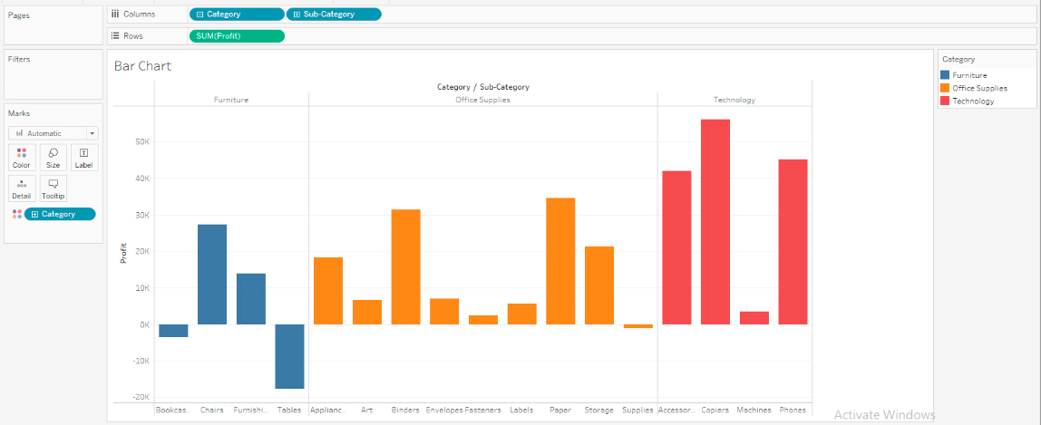
    2. 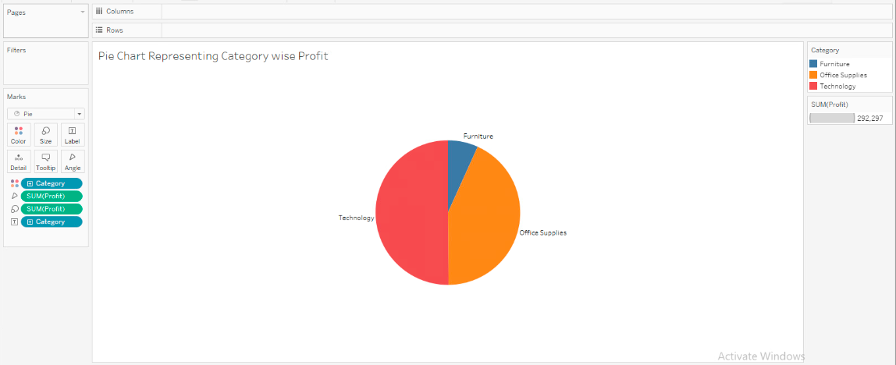
13. Create the line chart
    1. 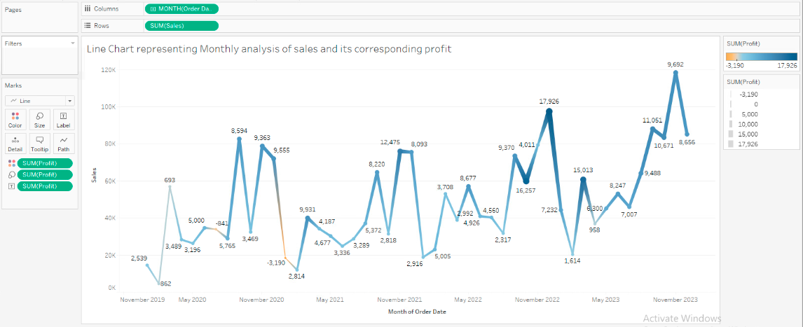
14. how to create the donut chart
    1. Steps to create donut chart
       1. Open Tableau and connect to your data source
       2. Drag the fields you want to use for your chart onto the Rows and Columns shelves
       3. Create a new worksheet and drag the fields you want to use onto the view
       4. Change the chart type to pie chart
       5. Right-click on the chart and select 'Add' -> 'Dual Axis'
       6. Right-click on the second axis and select 'Synchronize Axis'
       7. Change the mark type for the second axis to 'Circle'
       8. Adjust the size of the circles to create the desired donut shape
       9. Format the chart as desired, including adding labels and colors
       10. Save and share your chart!
    2. 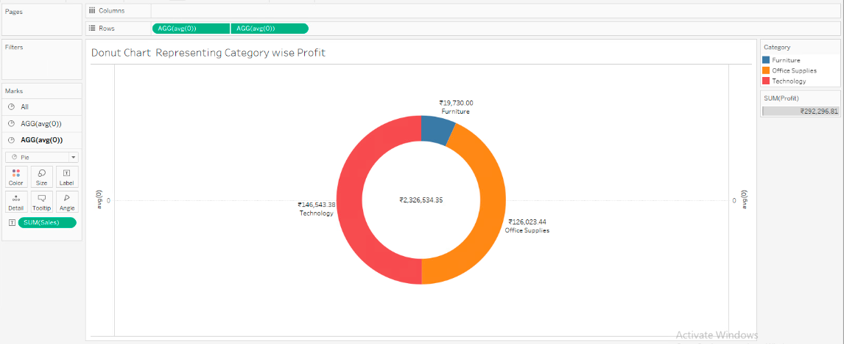
15. Create a map to display state wise sales
    1. 